**CHAPTER ONE**

**INTRODUCTION**

* 1. **Introduction**
     1. **Social** **network**

When you hear the term social network, you may immediately think of Facebook or Twitter. You’re right Those are types of online social networks! Let’s think offline for a moment though. In the offline world, social networks refer to the social ties that link us together with other people. These ties include your family, friends, acquaintances, neighbors, etc. but will talk now about family networks from point of view technology.

define social network is services that allow individuals to construct a public or semi-public profile within a bounded system, articulate a list of other users with whom they share a connection, and view their list of connections by others in system.

The nature and nomenclature of these connections may vary from network to other.

While we use the term "social network sites" to describe this phenomenon, and the two terms are often used interchangeably. We chose not to employ the term "social network sites" for reason: scope (platform). [1]

What makes social network unique is not that they allow individuals to meet strangers, but rather that they enable users to articulate and make visible their social.

Profiles are unique pages where one can "type oneself into being" After joining a social network, an individual is asked to fill out forms containing a series of questions. The profile is generated using the answers to these questions, which typically include descriptors such as age, location, interests, and an "about me" section. Most sites also encourage users to upload a profile photo. Some social network allows users to

enhance their profiles by adding multimedia content or modifying their profile's look and feel. others, such as Facebook, allow users to add modules Applications that enhance their profile. social network can view each other's profiles, unless a profile owner has decided to deny permission to those in their network.

Structural variations around visibility and access are one of the primary ways that social network differentiate themselves from each other.

After joining a social network site, users are prompted to identify others in the system with whom they have a relationship. The label for these relationships differs depending on the site popular terms include "Friends," "Contacts," and "Fans." Most social network require bidirectional confirmation for Friendship, but some do not. These one-directional ties are sometimes labeled as "Fans" or "Followers," but many sites call these Friends as well. The term "Friends" can be misleading, because the connection does not necessarily and not Know the other party.

Most social network also provide a mechanism for users to leave messages on their Friends' profiles. This feature typically involves leaving "comments," although sites employ various labels for this feature. In addition, social network often has a private messaging feature similar to mail. While both private messages and comments are popular on most of the major social network, and not all social network began with messaging service.

beyond profiles, Friends, comments, and private messaging, social network varies greatly in their features and user base. Some have photo-sharing or video-sharing capabilities; others have built-in blogging and instant messaging technology. There is mobile-specific social network (e.g. Dodgeball), but some web-based social network also supports mobile interactions (e.g., Facebook). and will can show in figure 1.1 what services users use in social networks. [1]

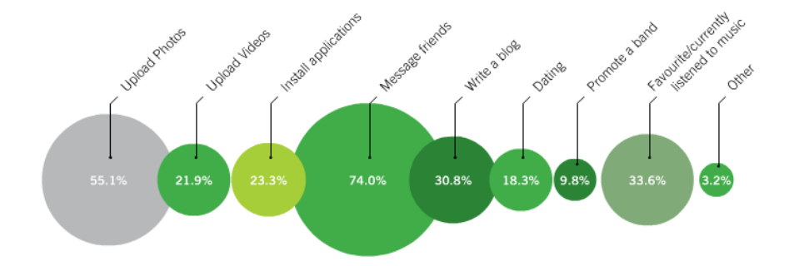

Figure 1.1 Services Social Network [1]

**1.1.2 Family social network**

If we want to talk about family networks we will re-mention all the previous services and include it in a group representing each group is one family, that allows access only to family members belonging to this group. They uniquely deliver, “true privacy” and security for both users (families) and data.

**1.1.3 Android**

Android operating system (OS) is widely used by smart phones and tablets. It was originally developed by company with same name (Android) in 2005, as part of Google strategy to enter the mobiles domain, now also used in TVs. It's purchased Android and took over its development work (as well as its development team). [2]

Google intend to make Android to be free, hence, most of Android ‘codes were released under the open-source Apache License, which means that anyone who wants to use Android can do so by downloading the full Android source code.

Moreover, vendors (typically hardware manufacturers eq. Samsung, Huawei) can add their own proprietary extensions to Android and customize Android to differentiate their products from others. This simple development model makes Android very attractive and has thus piqued the interest of many vendors. This has been especially true for companies affected by the phenomenon of Apple’s iPhone, a hugely successful product that revolutionized the Smartphone industry.

Android has taken the world by storm, everybody wants a Smartphone or tablet, and Android devices became hugely popular. Android powers hundreds of millions of mobile devices in more than 190 countries around the world. It's the largest installed base of any mobile platform and growing fast. Every day more than 1 million new Android devices are activated worldwide.

User interaction with an android device is primarily visual and tactile in nature. All these interactions took a place through the user interface of the applications that are installed on devices. Including both the built-in applications and any third-party application installed by the user. The spread of variety of Android applications.

The version history of the Android mobile operating system began with the release of Android alpha in November 5. 2007. The first commercial version, Android 1.0, was released in September 2008. Android is continually developed by Google and the Open Handset Alliance, and it has seen a number of updates to its base operating system since the initial release.

Versions 1.0 and 1.1 were not released under specific code names, but since 2009's Android 1.5 Cupcake, Android versions have had confectionery-themed code names. Each is in alphabetical order, with the most recent major version being Android 8.0 Oreo, released to the public on August 21, 2017. [3]

**1.2 Background**

exist several projects Related with family social network like [23snaps](http://www.23snaps.com/) and JustFamily for share photos only with family, FamilyWall, eFamily, [Family Crossings](http://www.familycrossings.com/family_files.html) and MyFamily, each project have positive and negative points, in chapter two will review details each project for show services ,Points of strength and weakness.

**1.3 Problem Statement**

The problem handled in this project can be described as follow:

On public social networking sites like Facebook we share our day to day activities with our friends and acquaintances, on LinkedIn we share our professional interest and experiences, but where do we share our intimate family moments? Is it time to go for a private social network App to stay connected with the people that matters most in our lives with increase communication between family and exist several apps family social network but have some problems such as not exist any app support Arabic language and not exist any app that combines all features.

**1.4 Scope**

This App for support families and every member wants to increase communication with their family.

**1.5 Objectives of the Project**

In this project, will develop app that is easy to use and can help the families in increase communication media between members.

I seek to achieve some of the objectives, these such as:

* Increase communication between members family.

to Organize family matters.

* A platform for displaying family matters.
* Support Arabic language for Arabic users.
* be application that combines all the features.

**1.6 Project Motivation**

In this project will learn several technologies for implantation project with huge Experience in the end road semester (android, NoSQL Database (Firebase) and Google API).

**1.7 Contribution**

The main contributes is to desire new application which is called family social network for some problems and to achieve increase communication media between members easier than before and help the families to solve the problem.

**1.8 Organization of the chapter**

**Chapter.1 Introductions**

**Chapter.2 related works**

This chapter will present the theoretical background of the project and some of the similar works presented currently, advantage, disadvantage and some comparison.

**Chapter.3 system analysis**

In this chapter, a detailed analysis of the systems, project mythology and talk about system planning and requirements of it you find it in.

**Chapter.4 system design and implementation**

This chapter contains how the proposed system is implemented and the methods used to that.

**Chapter.5 results and discussion**

This chapter will discuss the results obtained from the proposed and implemented system. And what we have realized in this project.

**Chapter.6 conclusions and future works.**

**CHAPTER TWO**

**BACKGROUND AND RELATED WORKS**

**2.1 Introduction**

Don’t lose focus, Social networks are supposed to keep us connected to our loved ones, improve communication & engagement between us. But unfortunately, many of the regular social networking sites are becoming a place for getting exposed to violent content, marketing stunts and cyber bullying. we are becoming so engaged and disturbed by these things, we are losing focus from the people for whom we have started using social media in the first place our families.

Facebook, Twitter, Instagram and the like have the potential to connect and engage people of all backgrounds. After all, where else can you connect with your grandma and high school best friend at the same time? Social media has the ability to spread news across the world faster than your Aunt Sally’s latest gossip at a family reunion. It can make us feel connected to others and part of a community. [4]

All that can happen through a few clicks of a mouse as you sit at home. Yes, social media is weird. Weird, wonderful and powerful, but often it may be the opposite.

For privacy and security reasons, public social networks are not ideal for sharing or communicating intimate family moments. For sharing the most intimate and private emotions with your family you need an environment which is a bit more personal, which not only connects you to your family, but also allows you to inspire each other to be active and appreciate your each other without unnecessarily broadcast everything to the whole world because,

Every day, many people publish clips and pictures of them inadvertently that lead to the destruction of their lives and their entry into difficult psychological situations after convert these memories to ridicule and laughter. Our goal in this project is to take away the monster’s teeth and claws. I want to build family social media simple and manageable for you and your family with top privacy. [5]

**2.2 Theoretical background**

on public social networking sites like Facebook we share our day to day activities with our friends and acquaintances, on LinkedIn we share our professional interest and experiences, but where do we share our intimate family moments and Family dialogues? Is it time to go for a private social media App to stay connected with the people that matters most in our lives, in this project I will build family social network (app Android), Allow to member communication with other member from family by using all features in app with share information between them with save privacy for families.

**2.3 Related Application**

In searching about new ideas for our project, found related works to our project, here are some private family social networks, some websites, some apps, some both, where you can feel free to share privately with just a small group of family members or a larger extended family group. Many of them are similar and each one has a different advantage, I will list them: -

#### 2.3.1 [23snaps](http://www.23snaps.com/)

#### Share photos privately with your family online, on your computer, tablet or smartphone And, this easy to use app is free! If you want, you can invite friends to receive updates by email. And you can have photobooks made from your pictures. If you are an Instagram user, you can now automatically post to 23snaps from your Instagram account just by adding #23snaps in your Instagram photo description, can be renamed (Instagram For Family) and in Figure 2.1 can show home page. [6]

#### 

#### Figure 2.1 Home Page 23snaps

#### 2.3.2 JustFamily

#### with JustFamily, share photos among family members, because let's face it: your dad isn't the best at typing. users can save, organize and share photos, as well as include a short message or caption with each. with an iOS app, downloadable windows uploader and web app, JustFamily shares your photos regardless of the device on which you captured them and in Figure 2.2 can show home page. [7]

#### 

#### Figure 2.2 Home Page JustFamily

#### 2.3.3 FamilyWall

#### FamilyWall like family social media other, adding a few features, such as a calendar and private messaging. The maps in the mobile version might help parents keep track of their wandering teenagers. Instead of asking kids to send a text when they arrive at a friend's house, parents can simply ask them to check in so they can view the location and in Figure 2.3 can show home page. [8]

#### 

#### Figure 2.3 Home Page FamilyWall

#### 2.3.4 eFamily

#### eFamily the social network formerly known as Famiva, boasts a family tree and stories section in addition to the features included on FamilyWall. eFamily stands out with its reminders feature: Create a shared reminder for making beds, remembering lunch money or picking up milk on the way home from work. One downside to eFamily: The design is fairly outdated and cluttered compared to competitors and in Figure 2.4 can show home page. [9]

#### 

#### Figure 2.4 Home Page eFamily

### **2.3.5** [**Family Crossings**](http://www.familycrossings.com/family_files.html)

#### While most "family" social networks are just privatized Facebook lookalikes, Family Crossings takes social media to a whole new familial level. Because families share more than photos, videos and the occasional party invite, Family Crossings allows users to share recipes, addresses, coupons, software and files and even post to family forums (for example: My potty-mouthed baby keeps escaping from his crib, any ideas?). Family Crossings provides rules and etiquette on table manners, as well as tips to make the most from your calendar and photo sharing.

#### Free accounts get only 250 MB of cloud storage, but standard $19.95/year for 350 MB or premium versions $9.95/month for 500 MB versions and in Figure 2.5 can show home page. [10]

#### 

#### Figure 2.5 Home Page Family Crossings

#### 2.3.6 MyFamily

#### Like Family Crossings, MyFamily.com offers a Facebook-like experience with a wealth of extra features. The site has all the basics that Facebook users have grown accustomed to, with a few tweaks. Each family receives unlimited storage to save and share files, defaulted privacy settings (only invited family members can join), the ability to create family trees (courtesy of Ancestry.com) and discussion boards. MyFamily.com's services ring up at $29.95 per year, which isn't too bad if you split the cost among family members but retired now and in Figure 2.6 can show home page. [11]

#### 

#### Figure 2.6 Home Page MyFamily

Table 2.1. Shows the Comparison between related works.

Table 2.1: Comparison Between Related Works

|  |  |  |  |  |  |  |
| --- | --- | --- | --- | --- | --- | --- |
| **MyFamily** | [**Family Crossings**](http://www.familycrossings.com/family_files.html) | **eFamily** | **FamilyWall** | **JustFamily** | [**23snaps**](http://www.23snaps.com/) | **#** |
| retired now | Posts, share recipes, address, software and files, post to family forums and provides rules and etiquette e.g. table manners | Posts, family tree, shared reminder, Home Needs (Purchases) and stories section | Posts, calendar, private messaging and help parents follow wandering teenagers on map | share photos with family | share photos with family and connected with Instagram | Services with advantage |
| retired now | Free accounts only 250 MB, standard $19.95/year for 350 MB and premium versions $9.95/month for 500 MB. | design is fairly outdated |  | Only share photos and limit space (1GB) for free | Only share photos | disadvantage |

**2.4 Recognition of needs**

From the previous table, I can conclude that, each project offers different services, all projects which allow to user sign in free, provide limited services with limit space on cloud storage and every project provide special services must user paying to obtain these services.

This led to need new system for family social network collecting and provide all special services without limit on space cloud storage.

**CHAPTER THREE**

**PROJECT METHODOLDGY**

Information technology can mean the different between success and failure, can be a combination of hardware and software and services used to communication or to share information.

The world is moving towards diversity and difference, our vision in this project is to achieve the diversity in the idea of the project where our idea is slightly different from typical graduation projects, and the different in the goal that is to help the families increase communication between members.

This chapter provides the steps we have taken to design our App. Information system is a combination between system and information, system is a set of related components that produces specific results. When the user interacts with this component is defined the functional requirements of the system, and when the system shows its properties is defined the nonfunctional requirements of the system.

Information means the data how is managed and handles and processed in the system that is represented in DFD (Data Flow Diagram) and ERD (Entity Relation Diagram). And so on. This chapter and the following two chapters will provide our system life cycle that starts from planning, analyzing, design, implementation, and finally testing show in (figure 3.1).

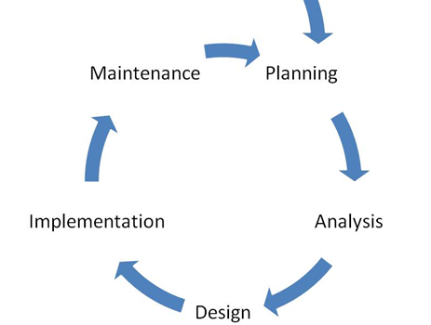

Figure 3.1 System Life Cycle

**3.1 Project Planning**

A system development methodology refers to framework that is used to structure, plan and contend the process of developing a system. It consists of the phases and actions taken to make the system come to light; this plan represents **Agile system** developments. Agile system development is an iterative software development which refers to a group of software development methodologies based on iterative development, where requirements and solutions evolve through collaboration between self-organizing cross-functional teams. Agile methods or agile processes generally promote a disciplined project management process that encourages frequent inspection and adaptation, leadership philosophy that encourages teamwork, self-organizing and accountability, a set of engineering best practices intended to allow for rapid delivery of high-quality software.

figure 3.2 represent the agile model that is composed on different phases. In this model phases are executed sequentially and in backtracking mode that means the system all the time performs a testing of the previous phases. [14]

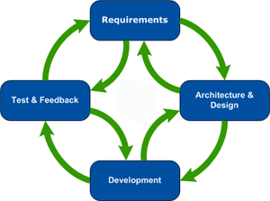

Figure 3.2 Agile Model [14]

**Requirements phases:**

This is the initial phase of the development process where in the development team works closely with the customer to determine the customer's requirements for the product. The requirements phase identifies the functionality, performance levels, and other characteristics which the product must satisfy in order for it to be acceptable to the customer. The requirements developed in this phase serve as a foundation for the remaining phases of the development process, and as the customer acceptance criteria.

**3.1.1 Feasibility Study**

Is the total of the actions can be taken and the questions can be asked to determine whether an idea, thought or plan is likely to succeed. An effective study can guide whether to move forward with your idea, refine it, or to stop it.

FSN System is an important system that is needed in every home these days because it increases communication between members families and it give you some new ideas.

This system is focusing on persons who has a problem in communication with family and organize family matters and save time for the user by provide direct connection and support language Arabic.

**3.1.2 Gantt Chart**

Gantt chart are useful in planning how long a project should take time and helping to organize the sequence of events by laying them out in the order in which the tasks need to be completed.

We built our Gantt chart step by step. That means, in each week we register what we have done and how many times it takes and we organize it in the following chart in figure 3.3 planning and analysis, figure 3.4 design and figure 3.5 Implementation and Testing.

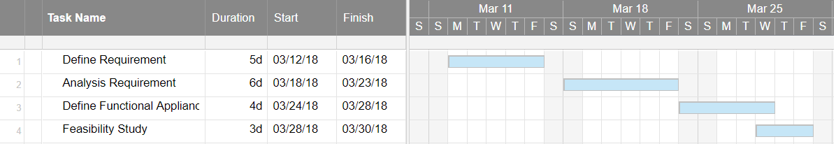

Figure 3.3 Planning and Analysis

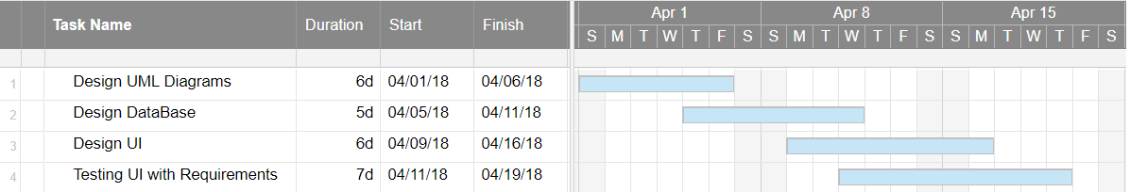

Figure 3.4 Design

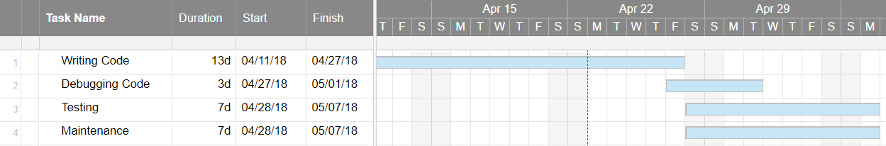

Figure 3.5 Implementation and Testing

**3.2 Analysis of the New System**

The analysis phase defines the requirements of the system, independent of how these requirements will be accomplished.

* + 1. **User Requirements**

**3.2.1.1 Functional Requirements**

Means how the system behaves from user point of view. Consider that our system is (FSN) information system, so it performs several functional requirements: -

* + - * Sign Up by Using Gmail.
* Authentication mobile number.
* Create a family.
* Add member to the family group.
* show the locations persons from family (automatic update location members of family).
* Any member of the family has access to the post (upload image with text and current location).
* Profile for the person content simple information.
* Put a box for renewed information such as family dates and important things.
* Determining the type of person (father, mother, child, etc.).
* feedback user can send feedback about any issue.

**3.2.1.2 Non-Functional Requirements**

Non-functional requirements place constraints on how the system will do so. The non-functional requirement elaborates a performance characteristic of the system.

**Availability**

The system should be available, or uptime, means that the should be operational and available to use. This is specified because some systems are designed with expected downtime for activities.

**Performance**

Performance requirements concern the speed of operation of a system. All the processes require fractions of second.

**Usability**

Usability is the ease with which a user can learn to operate, prepare inputs for, and interpret outputs of system or component.

**Reliability**

Reliability is the ability of a system to perform its required functions under stated conditions for a specific period of time.

**Efficiency**

The system should utilize the resources: memory, processor speed, etc., and use them in effectively and efficient ways.

**Modifiability**

Requirements about the effort required to make changes in the software. Often, the measurement is personnel effort(person-months).

**3.2.2 System Requirements**

**Hardware Requirements**

**Table 3.1 Hardware Requirements**

|  |  |
| --- | --- |
| **Specifications** | **Recommended Requirements** |
| Processor | 1.0 GHz or higher |
| Internal storage | 1 Gigabyte or higher |
| Memory | 512 MB or higher |
| Monitor | Touch screen 4 inches or higher |

**Software Requirements**

**Table 3.2 Software Requirements**

|  |  |
| --- | --- |
| **Specifications** | **Recommended Requirements** |
| Operating System | Android |
| Front –end | Xml |
| Backend | JAVA |
| Application Store | PlayStore |
| Server | Firebase |
| Integrated Development Environment (IDE) | Android Studio 3.0.1 |

**3.2.3 Domain Requirements**

Domain requirements are important because they often reflect fundamentals of the application domain. If these requirements are not satisfied, it may be impossible to make the system work satisfactorily.

* This mobile application shall be designed to meet need families with high database protection.
* This mobile application requires service Firebase from google for build database and make it cloud.
* The processing speed shall be fast and must be measured in unit of time eq. update locations every time.
* **NoSQL**

One of the most fundamental choices to make when developing an application is whether to use a SQL or NoSQL database to store the data. Conventional SQL (i.e. relational) databases are the product of decades of technology evolution, good practice, and real-world stress testing. They are designed for reliable transactions and ad hoc queries, the staples of line of business applications. But they also come burdened with restrictions—such as rigid schema—that make them less suitable for other kinds of apps. NoSQL databases arose in response to those limitations. NoSQL systems store and manage data in ways that allow for high operational speed and great flexibility on the part of the developers. Many were developed by companies like Google, Amazon, Yahoo, and Facebook that sought better ways to store content or process data for massive websites. Unlike SQL databases, many NoSQL databases can be scaled horizontally across hundreds or thousands of servers. NoSQL databases can store non-relational data on a super large scale and can solve problems regular databases can't handle: indexing the entire Internet, predicting subscriber behavior, or targeting ads on a platform as large as Facebook. over 150 NoSQL database types exist now. [12]

* **Firebase**

Firebase is a mobile and web app development platform that provides developers with a plethora of tools and services to help them develop high-quality apps, grow their user base, and earn more profit. A Brief History, In April 2012, Firebase was created as a separate company that provided Backend-as-a-Service with real-time functionality. After it was acquired by Google in 2014, Firebase rapidly evolved into the multifunctional behemoth of a mobile and web platform that it is today. [13]

* **Firebase Services**

Firebase Services can be divided into three groups and can show in figure 3.6 service of Firebase: -

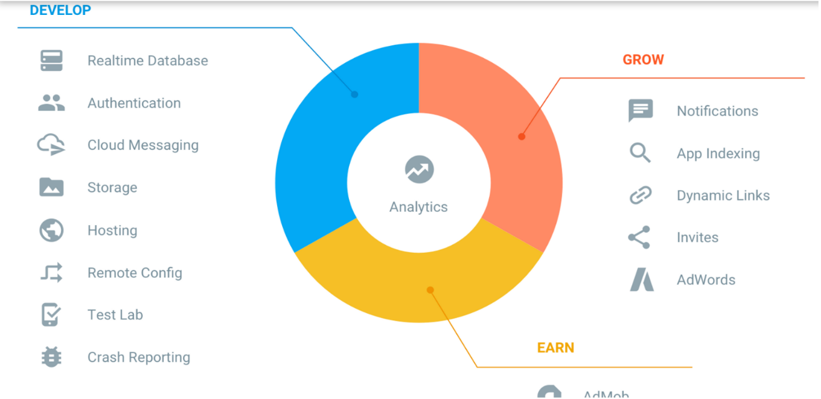

Figure 3.6 firebase services

this simple explanation for each service, [Cloud Functions is](https://firebase.google.com/products/functions/)run mobile backend code without managing servers, [Authentication](https://firebase.google.com/products/auth/) is Authenticate users simply by Gmail or facebok … etc. securely, [hosting](https://firebase.google.com/products/hosting) is deliver web app assets with speed and security, [Cloud Storage](https://firebase.google.com/products/storage/) is store and serve files at Google scale, [Realtime Database](https://firebase.google.com/products/database) is store and sync app data in milliseconds, [Google Analytics](https://firebase.google.com/products/analytics/) is get free and unlimited app analytics, [Cloud Messaging](https://firebase.google.com/products/cloud-messaging/) is send targeted messages and notifications, [Remote Config](https://firebase.google.com/products/remote-config/) is modify your app without deploying a new version, [Dynamic Links](https://firebase.google.com/products/dynamic-links/) is drive growth by using deep links with attribution, [App Indexing](https://firebase.google.com/products/app-indexing/) is drive search traffic to your mobile app, [Test Lab](https://firebase.google.com/products/test-lab/) is test your app on devices hosted by Google. [13]

# **CHAPTER FOUR**

# **SOFTWARE DESIGN AND IMPLEMENTATION**

In system design phases, we will describe the system requirements, operating environment, system and subsystem architecture (Use Case Model, Sequence Diagram, Activity Diagram, GUI Screens).

# **4.1 Use Case Diagram**

A Use Case Model describes the proposed functionality of a new system. A Use Case represents a discrete unit of interaction between a user and the system. Each Use Case describes the functionality to be built in the proposed system, which can include another Use Case's functionality or extend another Use Case with its own behavior. From figure 4.1 it is clear that the App is directed toward user to inform and help him/her.

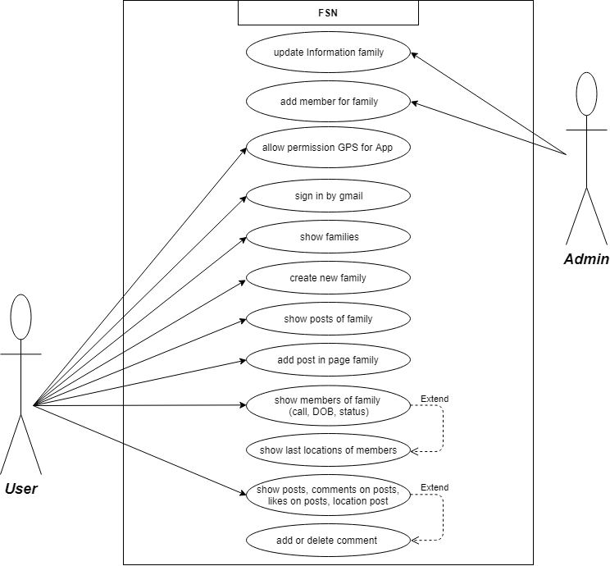

# Figure 4.1 Use case diagram

# **4.2 Class Diagram**

The class diagram describes the attributes and operations of a class and also the constraints imposed on the system. The class diagrams are widely used in the modeling of object-oriented systems because they are the only UML diagrams which can be mapped directly with object-oriented languages.

The class diagram shows a collection of classes, interfaces, associations, collaborations and constraints. It is also known as a structural diagram. In Figure 4.2 can show class diagram.

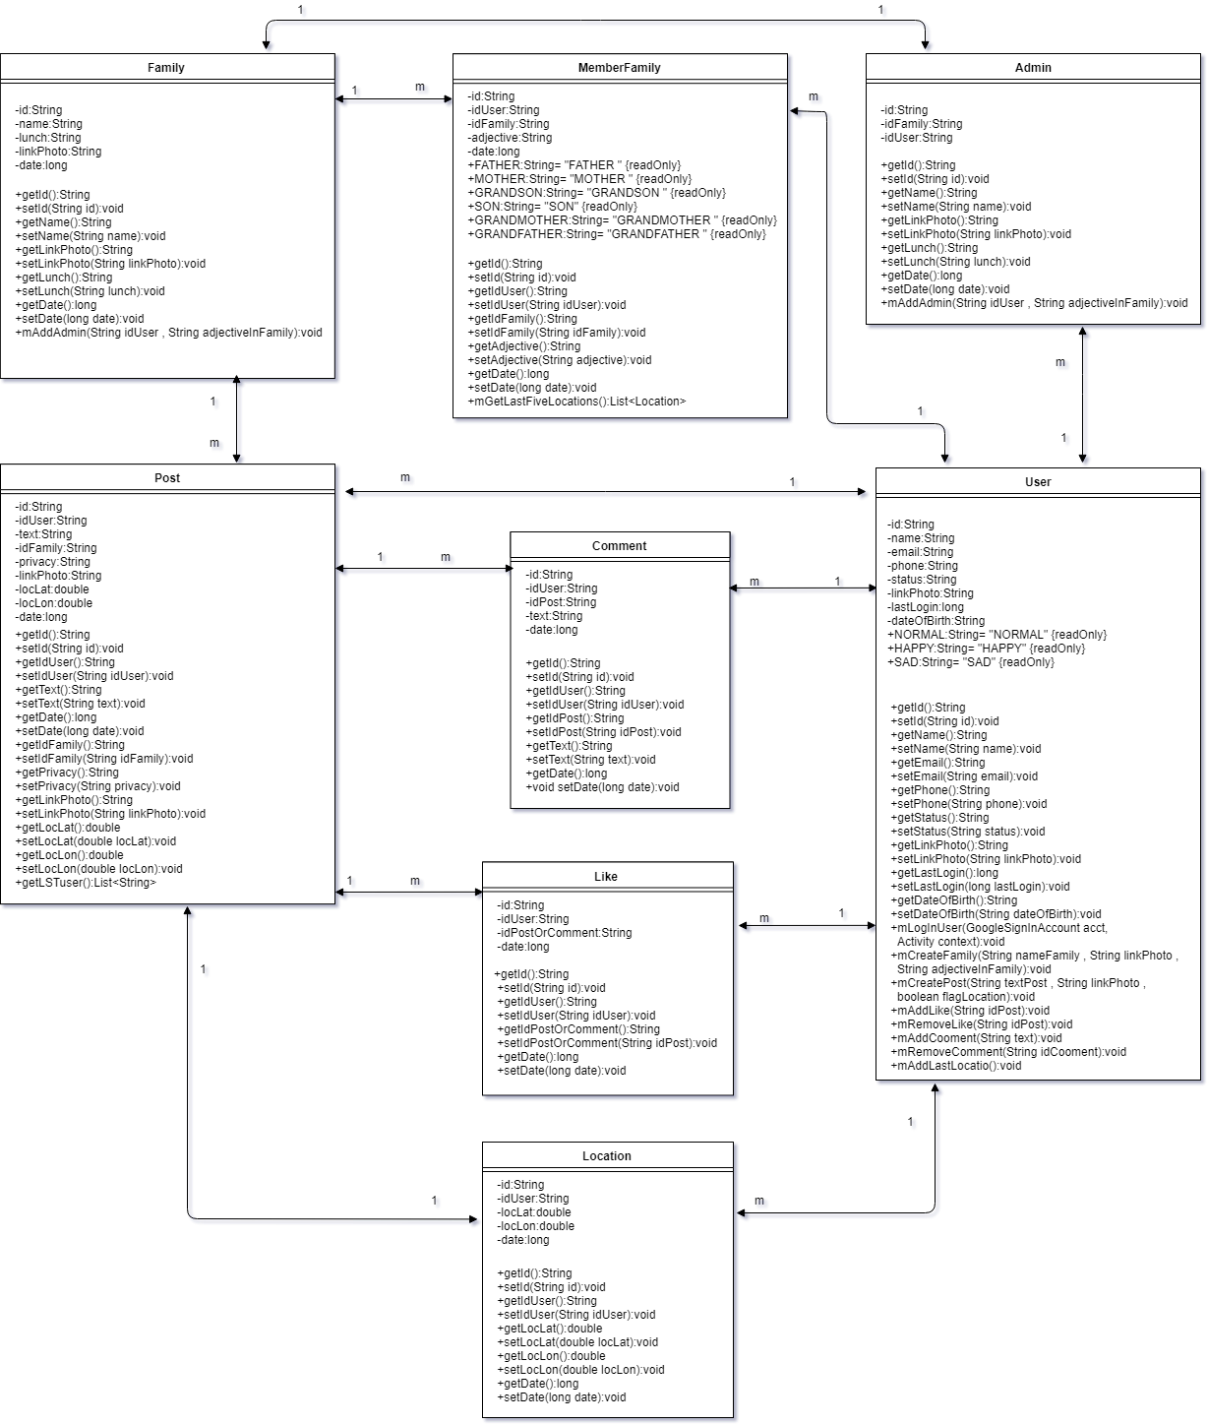

Figure 4.2 class diagram

# **4.3 Activity Diagram**

Activity diagram describes the flow of control in a system. It consists of activities and links. The flow can be sequential, concurrent, or branched.

Activities are nothing but the functions of a system. Numbers of activity diagrams are prepared to capture the entire flow in a system Activity diagrams are used to visualize the flow of controls in a system. This is prepared to have an idea of how the system will work when executed. In Figure 4.3 can show Activity diagram.

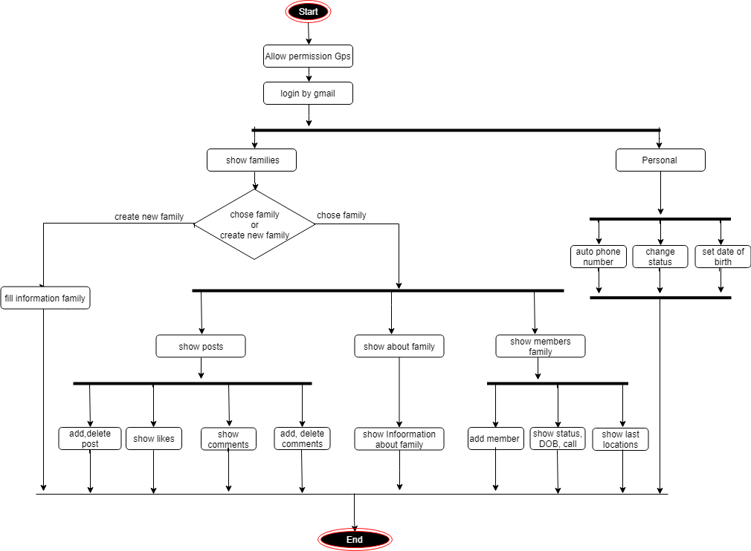

Figure 4.3 Activity diagram

# **4.4 Sequence Diagram**

A sequence diagram is an interaction diagram. From the name, it is clear that the diagram deals with some sequences, which are the sequence of messages flowing from one objector another.

Interaction among the components of a system is very important from implementation and execution perspective. Sequence diagram is used to visualize the sequence of calls in system to perform a specific functionality.

can be defined as the snapshot of the running system at a particular moment. In Figure 4.4 can show Sequence diagram for execute create new family.

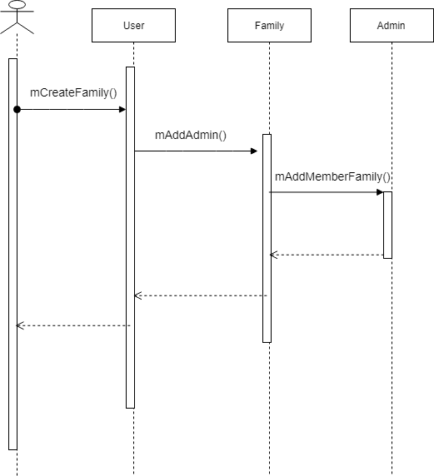

Figure 4.4 Sequence diagram

**4.5 Snapshot Firebase**

In this part you can show snapshot from Firebase in figure 4.5 can show how store database by key – Value, in figure 4.6 storage images on firebase and figure 4.7 for authentication and sign by Gmail.

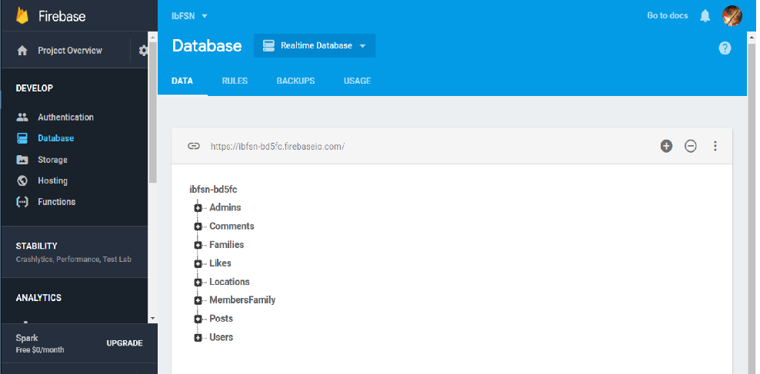

4.5 Database Key-Value

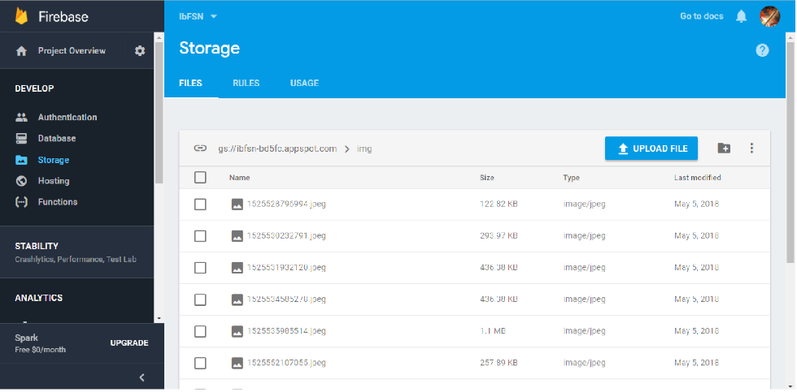

4.6 Storage images

# 

4.7 Authentication

# **4.6 Implementation**

In the software implementation phase, we will show how the system, user, and domain requirements have been implemented to produce completed system. Implementation refers to the final process of moving the solution from development status to production status. On receiving system design documents, the work is divided in modules/units and actual coding is started. Since, in this phase the code is produced so it is the main focus for the developer. This is the longest phase of the software development life cycle.

Here we will show the implementation phase by showing the final screens of the project and describing in details the functionalities that will be performed by the system through these screens.

* + 1. **App design (GUI Screens)**

This App is composed on nine related screens: -

**4.6.1.1 Login**

This screen very simple for allow take app permeation on GPS and Sign In by using Gmail, can show this in figure 4.8.

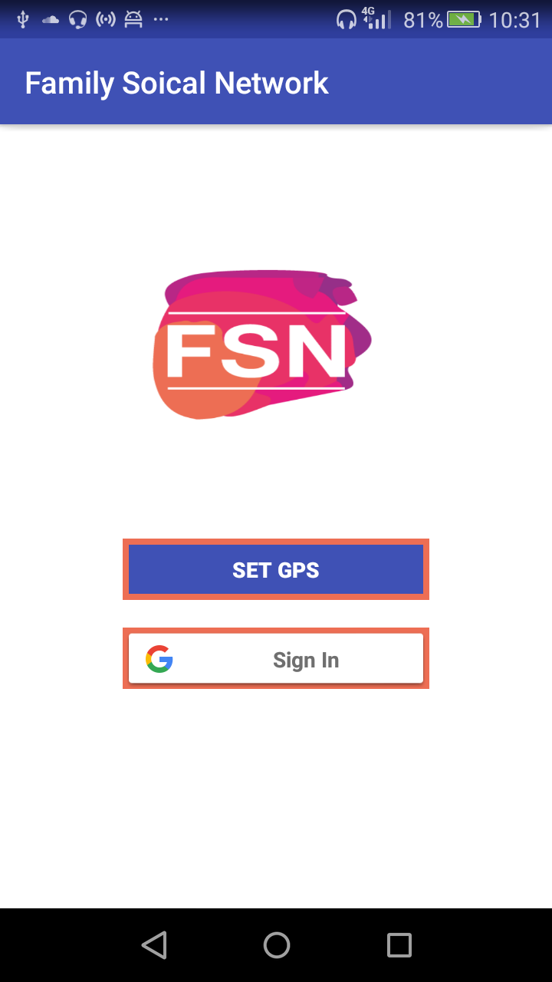

Figure 4.8 Login

**4.6.1.2 Families**

This screen content list families of user or other way all families exist user in members of family and floating button to open other screen create new family or chose one item from list view for open page family, can show this in figure 4.9.

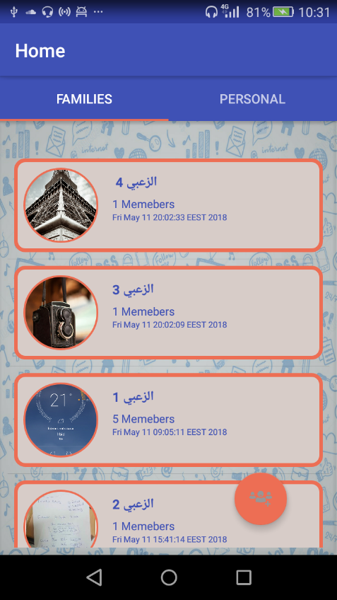

Figure 4.9 Families

**4.6.1.3 Create New Family**

This screen for create new family after specific name family, image family and adjective of creator in family, can show this in figure 4.10.

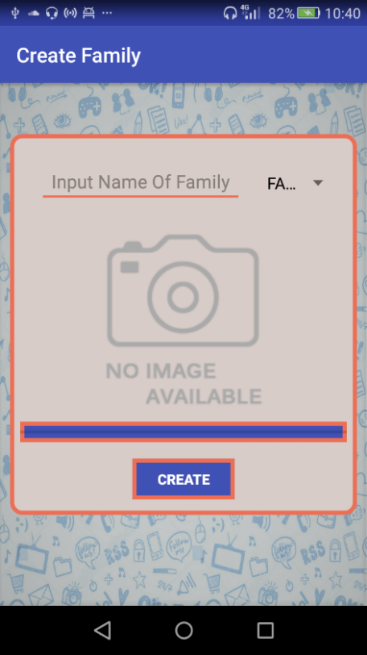

Figure 4.10 Create New Family

**4.6.1.4 Family**

This screen has three tabs (fragments), First tab posts this tab for show all posts of family, can open screen create new post for add post in page family, add like for post, open screen location of post and open screens comments of post, Second Tab members this tab has list view for show all members of family, show status of members, call with other member, open screen locations member, show date of birth members and admin of family will have floating button in this tab for add new member in family by email or mobile number of user, Third tab About, this tab has Information about family, can show this in figure 4.11, 4.12,4 and 4.13.

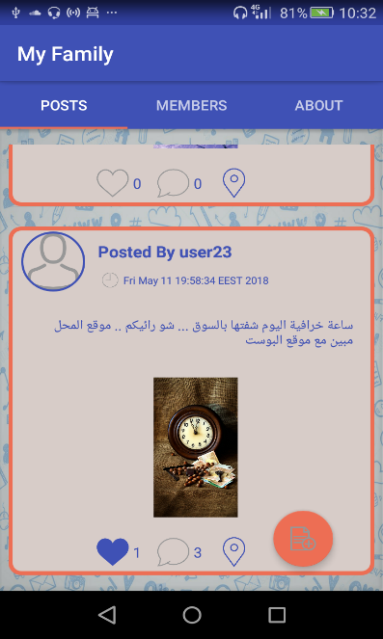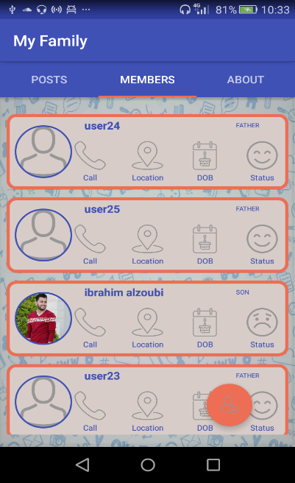

Figure 4.11 Posts Figure 4.12 Members

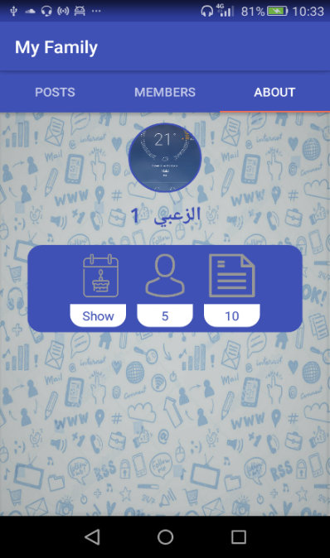

Figure 4.13 About Family

**4.6.1.5 Create New Post**

This screen for create and add post in page family after write text, chose permission location and chose image of post from storage phone, can show this in figure 4.14.

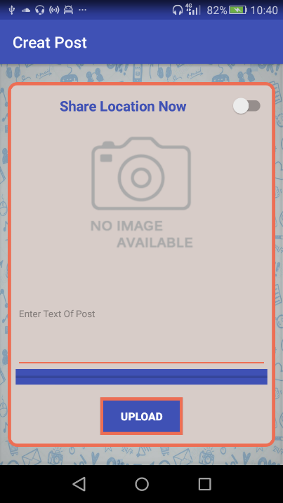

Figure 4.14 Create New Post

**4.6.1.6 Comments**

This screen for show all comments on specific post and can add comment on post, can show this in figure 4.15.

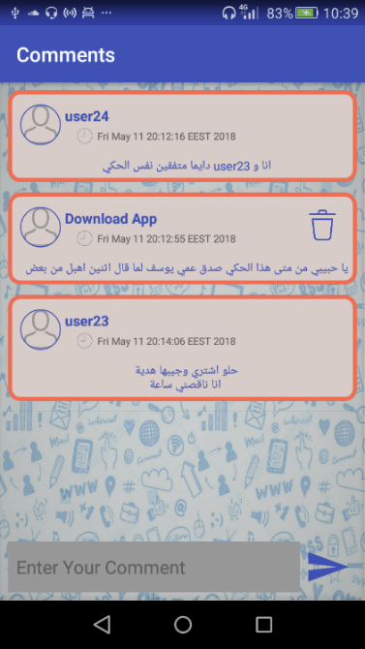

Figure 4.15 Comments

**4.6.1.7 Personal**

This screen for show number of families for user, set date of birth, set change status and authentication phone number, can show this in figure 4.16

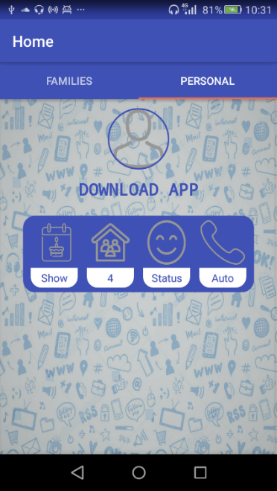

Figure 4.16 Personal

**4.6.1.8 Location Post**

This screen for show location of user on map in time add post, if creator post allows show location, can show this in figure 4.17.

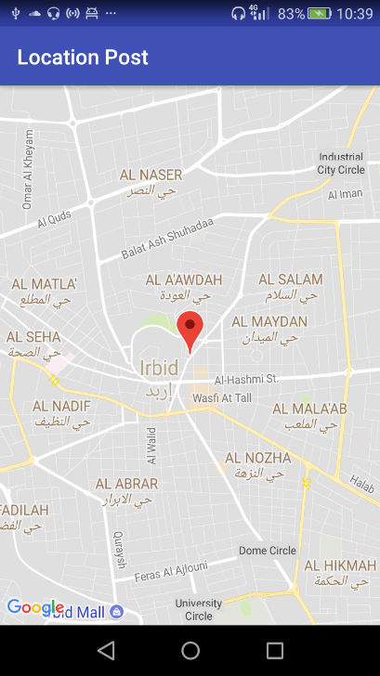

Figure 4.17 Location Post

**4.6.1.9 Locations User**

This screen for show last locations of user on map, has been recorded by app, can show this in figure 4.18.

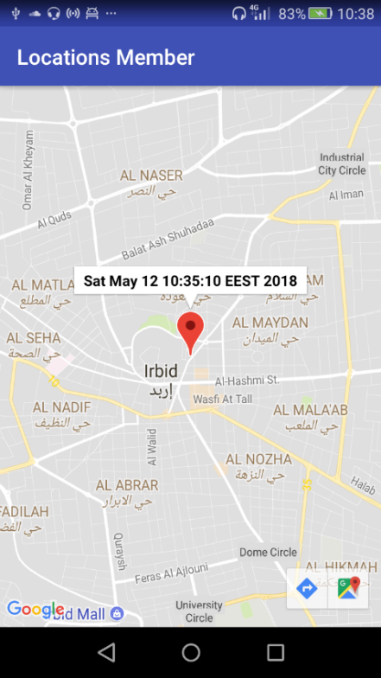

Figure 4.18 Location User

* + 1. **Snapshot Code**

from code for task Create New Family.

*// Create New Family*

*// mCreateFamily from class User***public void** mCreateFamily(String nameFamily , String linkPhoto , String adjectiveInFamily){  
  
 String familyId = AppRefDB.*RefFamilies*.push().getKey();  
 Family family = **new** Family( familyId ,nameFamily , linkPhoto);  
 AppRefDB.*RefFamilies*.child(familyId).setValue(family);  
  
 Main.*getInstance*().getMAPfamily().put(familyId , family);  
 family.mAddAdmin(Main.*user*.getId() , adjectiveInFamily);  
}

*// Add Admin  
// mAddAdmin from class Family***public void** mAddAdmin(String idUser , String adjectiveInFamily){  
  
 String idAdmin = AppRefDB.*RefAdmins*.push().getKey();  
 Admin admin = **new** Admin(idAdmin , getId() , idUser);  
 AppRefDB.*RefAdmins*.child(idAdmin).setValue(admin);  
  
 Admin.*mAddMemberFamily*( getId() ,idUser , adjectiveInFamily );  
}

*// Add new Member  
// mAddMemberFamily from class Admin***public void** mAddMemberFamily(String idFamily , String idUser ,String adjective){  
  
 String idMemberFamily = AppRefDB.*RefMembersFamily*.push().getKey();  
 MemberFamily memberFamily = **new** MemberFamily(idMemberFamily, idUser ,idFamily ,adjective);  
  
 Main.*getInstance*().getMAPmemberFamily().put(idMemberFamily , memberFamily);  
 AppRefDB.*RefMembersFamily*.child(idMemberFamily).setValue(memberFamily);  
}

**CHAPTER FIVE**

**RESULTS AND DISCUSSION**

**5.1 Result**

**5.1.1 Expected Result**

In this project, we were interested in developing an App for families to help members of family in increase communication media between members. The main idea, were to create App that is easy to use and efficient at the same time and can be accessed any time without constrains on the time and location and support Arabic language.

When studying the relevant works, found several apps with same work but without support Arabic language, constraint on space storage, pay for increase space and get professional services.

It is expected to allow App ready to provide several services, Authentication mobile number, Create a family, Add member to the family group, show the locations persons from family (automatic update location members of family), Any member of the family has access to the post (upload image with text and current location), Profile for the person content simple information, Put a box for renewed information important things, Determining the type of person (father, mother, child, etc.), feedback user can send feedback about any issue.

**5.1.2 Actual Results**

Now have terminated the work in semester and these requirements have been implemented in the application: -

• Sign Up by Using Gmail.

• Create a family.

• Add member to the family group.

• show the locations persons from family (automatic update location members of family).

• Any member of the family has access to the post (upload image with text and current location).

• Profile for the person content simple information.

• Determining the type of person (father, mother, child, etc.).

**5.2 Discuss**

After discussing the expected and actual results, the difference between them is clear. We have achieved Most of the expected work, In this project, developed app that is easy to use and can help the families in increase communication media between members Increase communication between members family such as Organize family matters, platform for displaying family matters, Supported Arabic language for users, be application that combines all the features.

But we encountered some of the problems in delay at the beginning of the semester and learn android development, Firebase and use API Google Map.

# **CHAPTER SIX**

**CONCLUSION AND FUTURE WORKS**

**6.1 Conclusion**

In this App, have created Family social network that will help members families increase communication media between activities in a special and distinctive in an easy, fast and sufficient.

Now have terminated the work in semester project graduation, we can have said that we have realized our objectives where main pillars were completed and developed an app that helps families in increase communication media between members.

Our goal were creativity and usability, also can be used by a large part of the families and learn huge experience in Android developer, Google API, NoSQL Database Firebase.

**6.2 Future Work**

In the near future, complete all requirements and add functionalities will be added to this system, these functions will be like:

1. Improved application design.
2. Show list likers of post.
3. Delete family.
4. Authentication mobile number.
5. Update image of family.
6. Add post only text.
7. Put a box for renewed information important things in about family.

**References**

[1] - Social Network Sites: Definition, History, and Scholarship danah m. boyd dmb@ischool.berkeley.edu School of Information University of California-Berkeley Nicole B. Ellison nellison@msu.edu Department of Telecommunication, Information Studies, and Media Michigan State University http://www.edidaktik.at/fachtagung08/trampedach_intro-to-social-networking.pdf

[2] - page 1 Wei-MengLee." beginning Android Application Development " .19 April 2011. Wrox; 1 edition. **ISBN-10:** 9781118017111.

[3] - AndroidTutorial.[Online].Available: <https://www.tutorialspoint.com/android/android_application_components.htm>.

[4] - <https://www.thriveglobal.com/stories/13064-why-do-you-need-a-family-app-to-stay-close-to-your-family>.

[5] - by [Shaon Shahnewaz](https://www.thriveglobal.com/authors/4035-shaon-shahnewaz), Technology & Social Media Blogger

<http://connectwithyourteens.net/private-family-social-networks/>

#### [6] - Available at:(<https://www.23snaps.com/>).

#### [7] - Available at:( <http://justfamily.com/Home/landing?ReturnUrl=%2f>).

#### [8] - Available at: - (https://www.familywall.com).

#### [9] - Available at: - (https://www.efamily.com/).

#### [10] - Available at: - (https://www.familycrossings.com/).

#### [11] - Available at: - (<https://www.ancestry.com/cs/myfamily>).

[12] - <https://www.infoworld.com/article/3240644/nosql/what-is-nosql-nosql-databases-explained.html>

[13] - <https://hackernoon.com/introduction-to-firebase-218a23186cd7>

[14] - http://www.myglobalit.com/blog/waterfall-vs-agile-models-software-development